Section 1: Write an application to perform basic arithmetic operations like add, subtract, multiply & divide . You need to define a functional interface first.

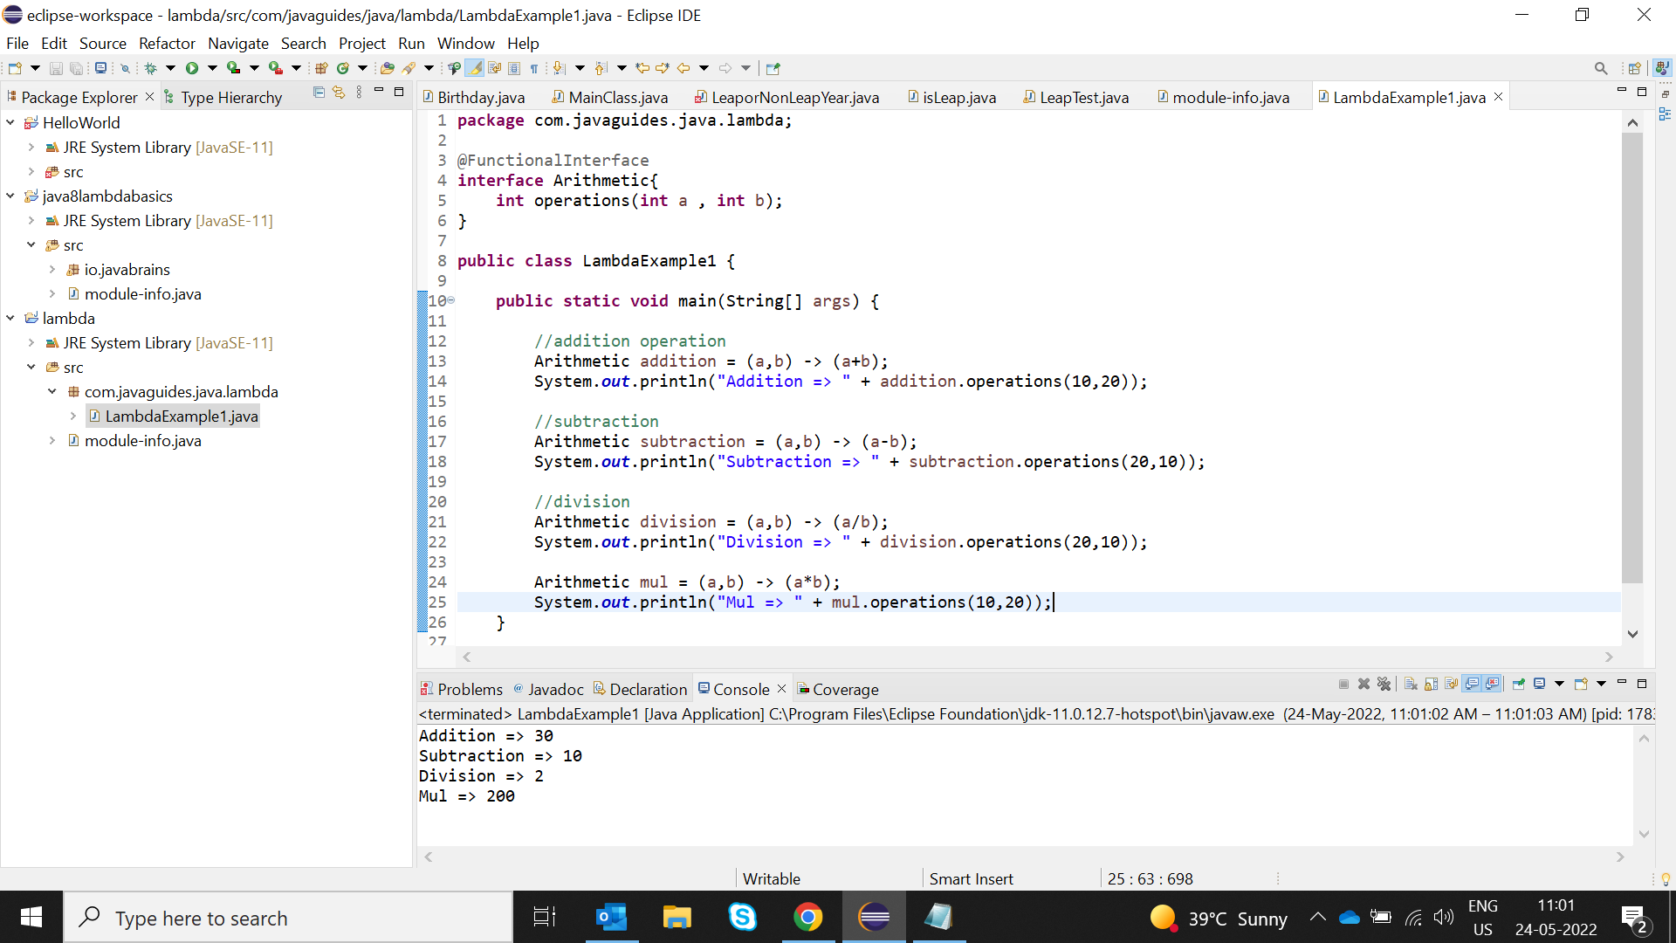

Section2: Write an application using lambda expressions to print Orders having 2 criteria implemented: 1) order price more than 10000 2) order status is ACCEPTED or COMPLETED.

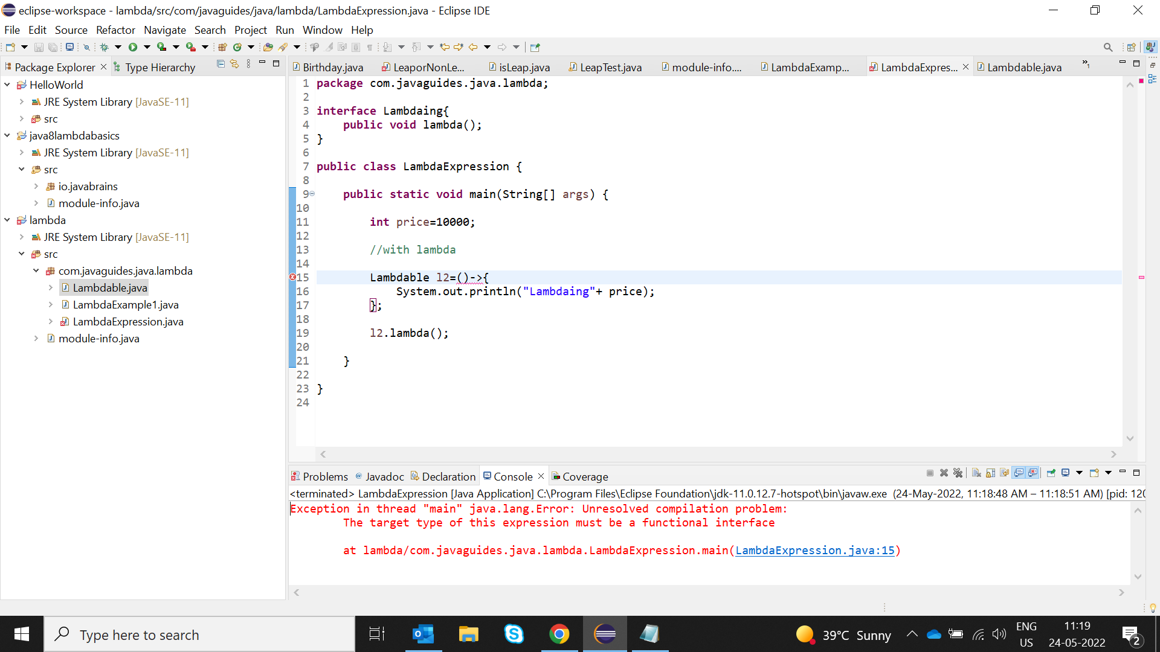

SECTION3: Use the functional interfaces Supplier, Consumer, Predicate & Function to invoke built-in methods from Java API.

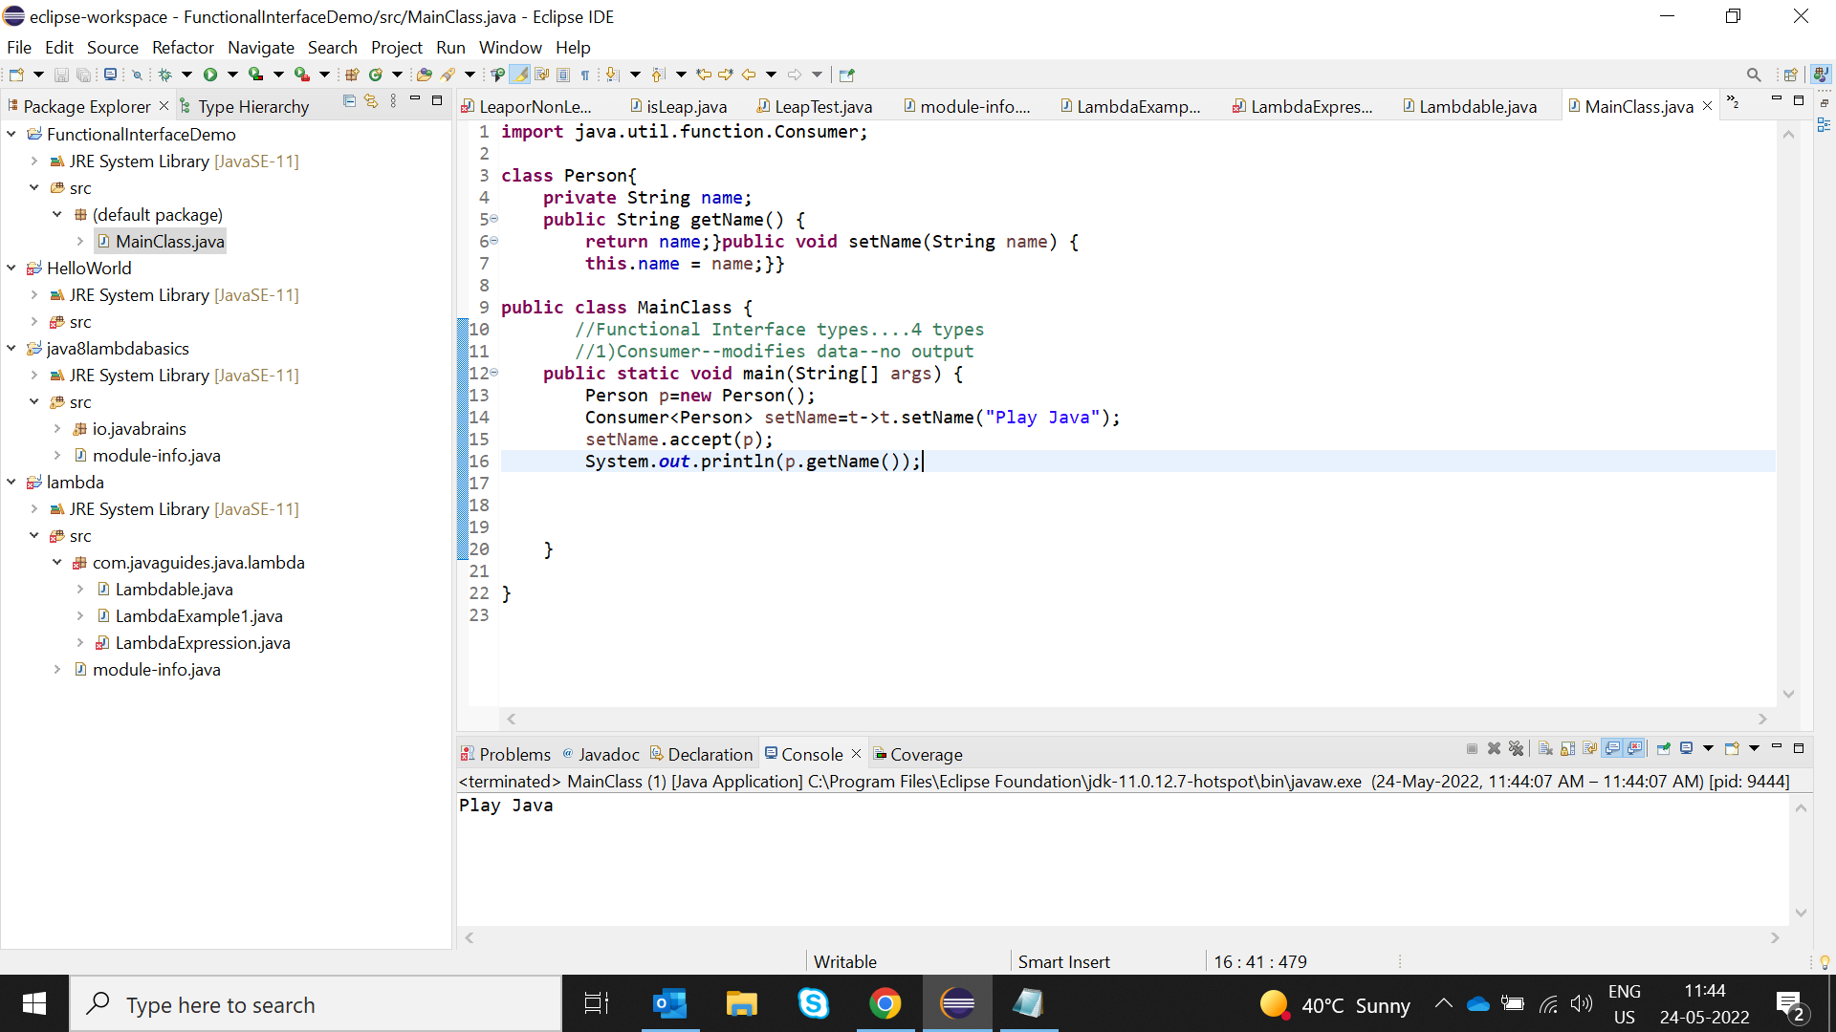

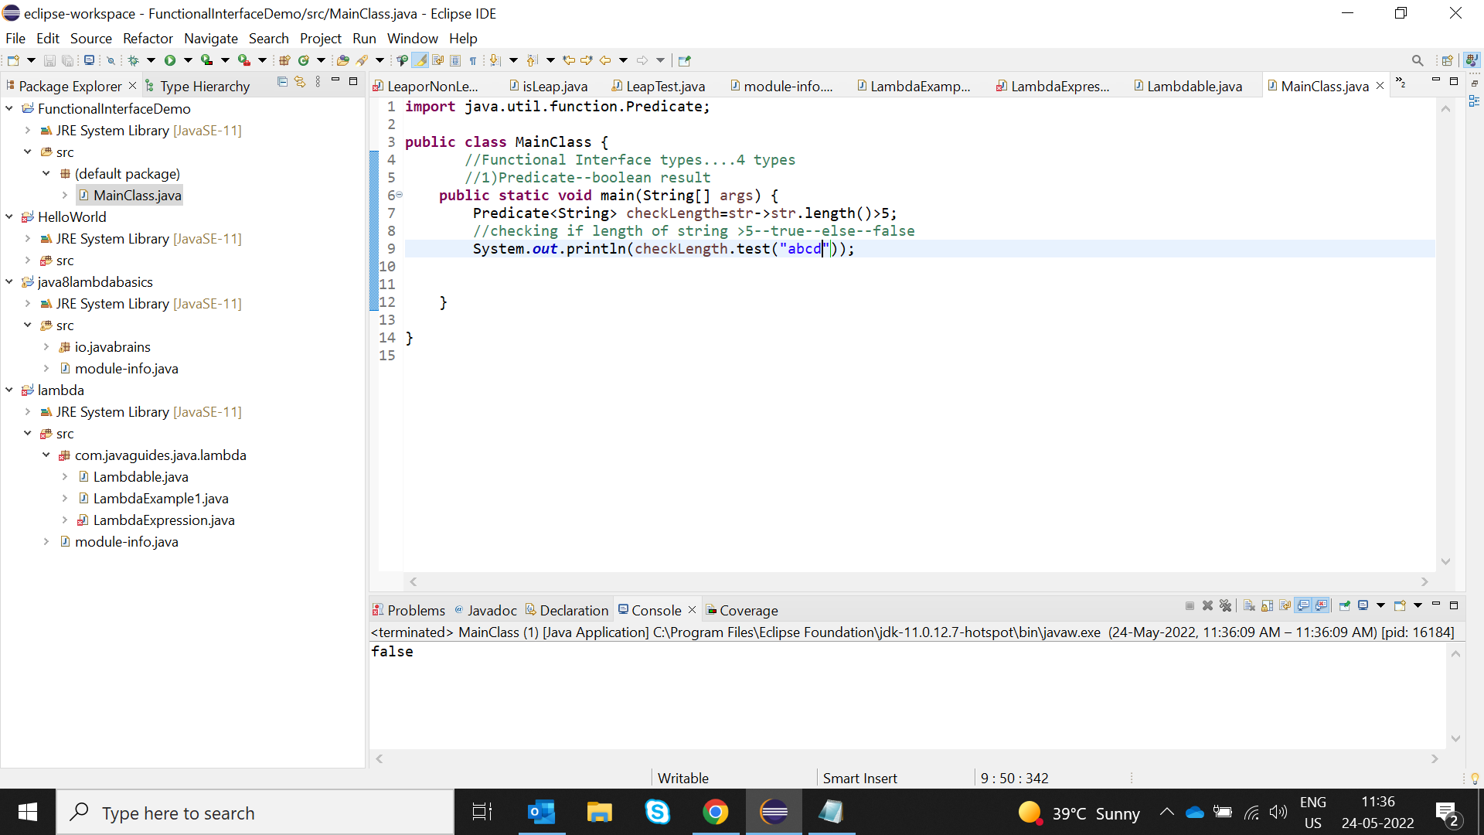

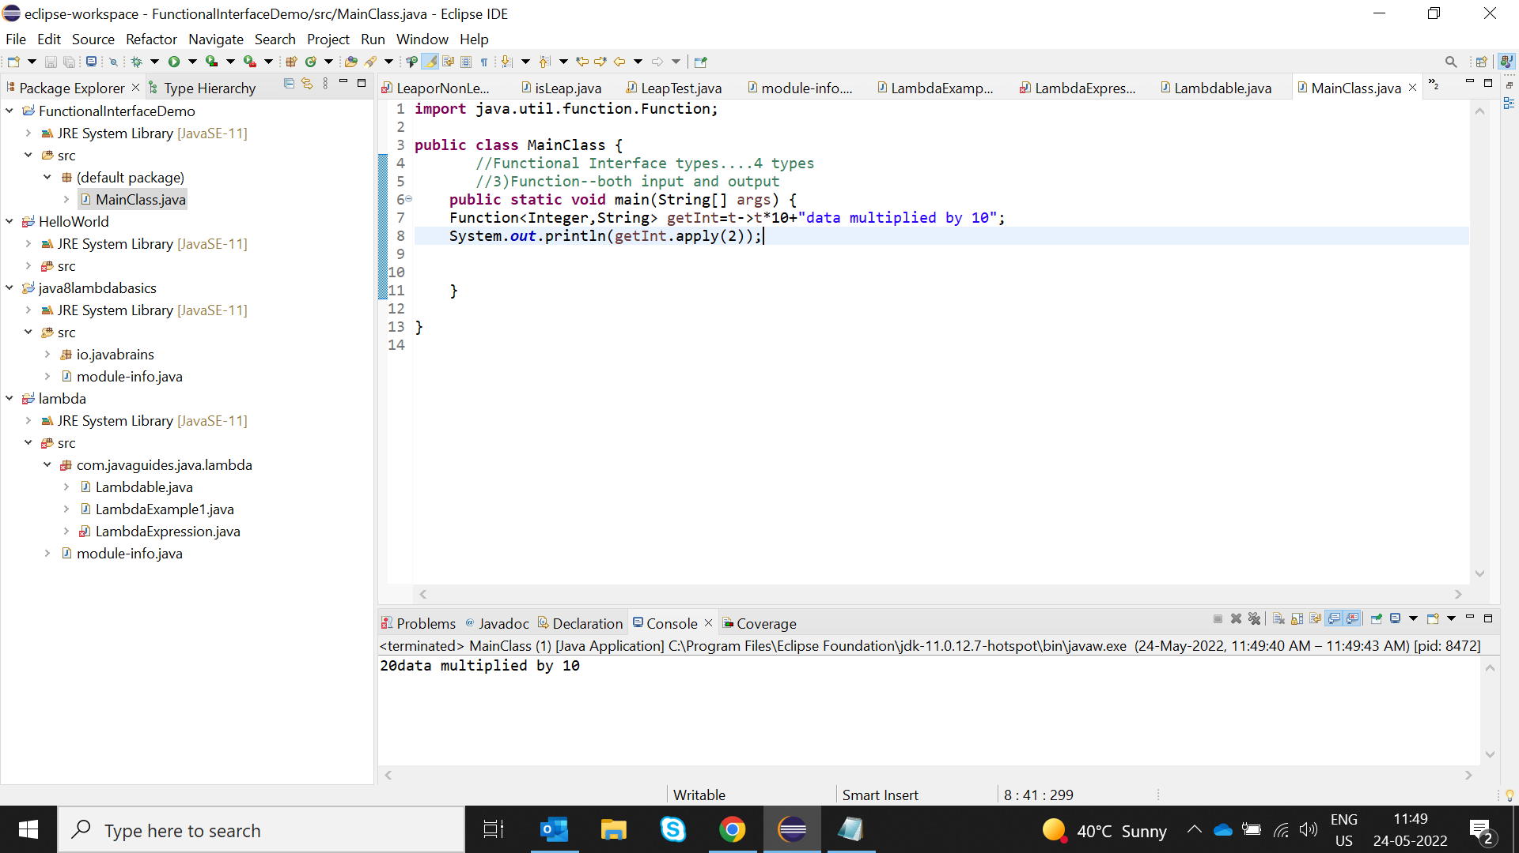

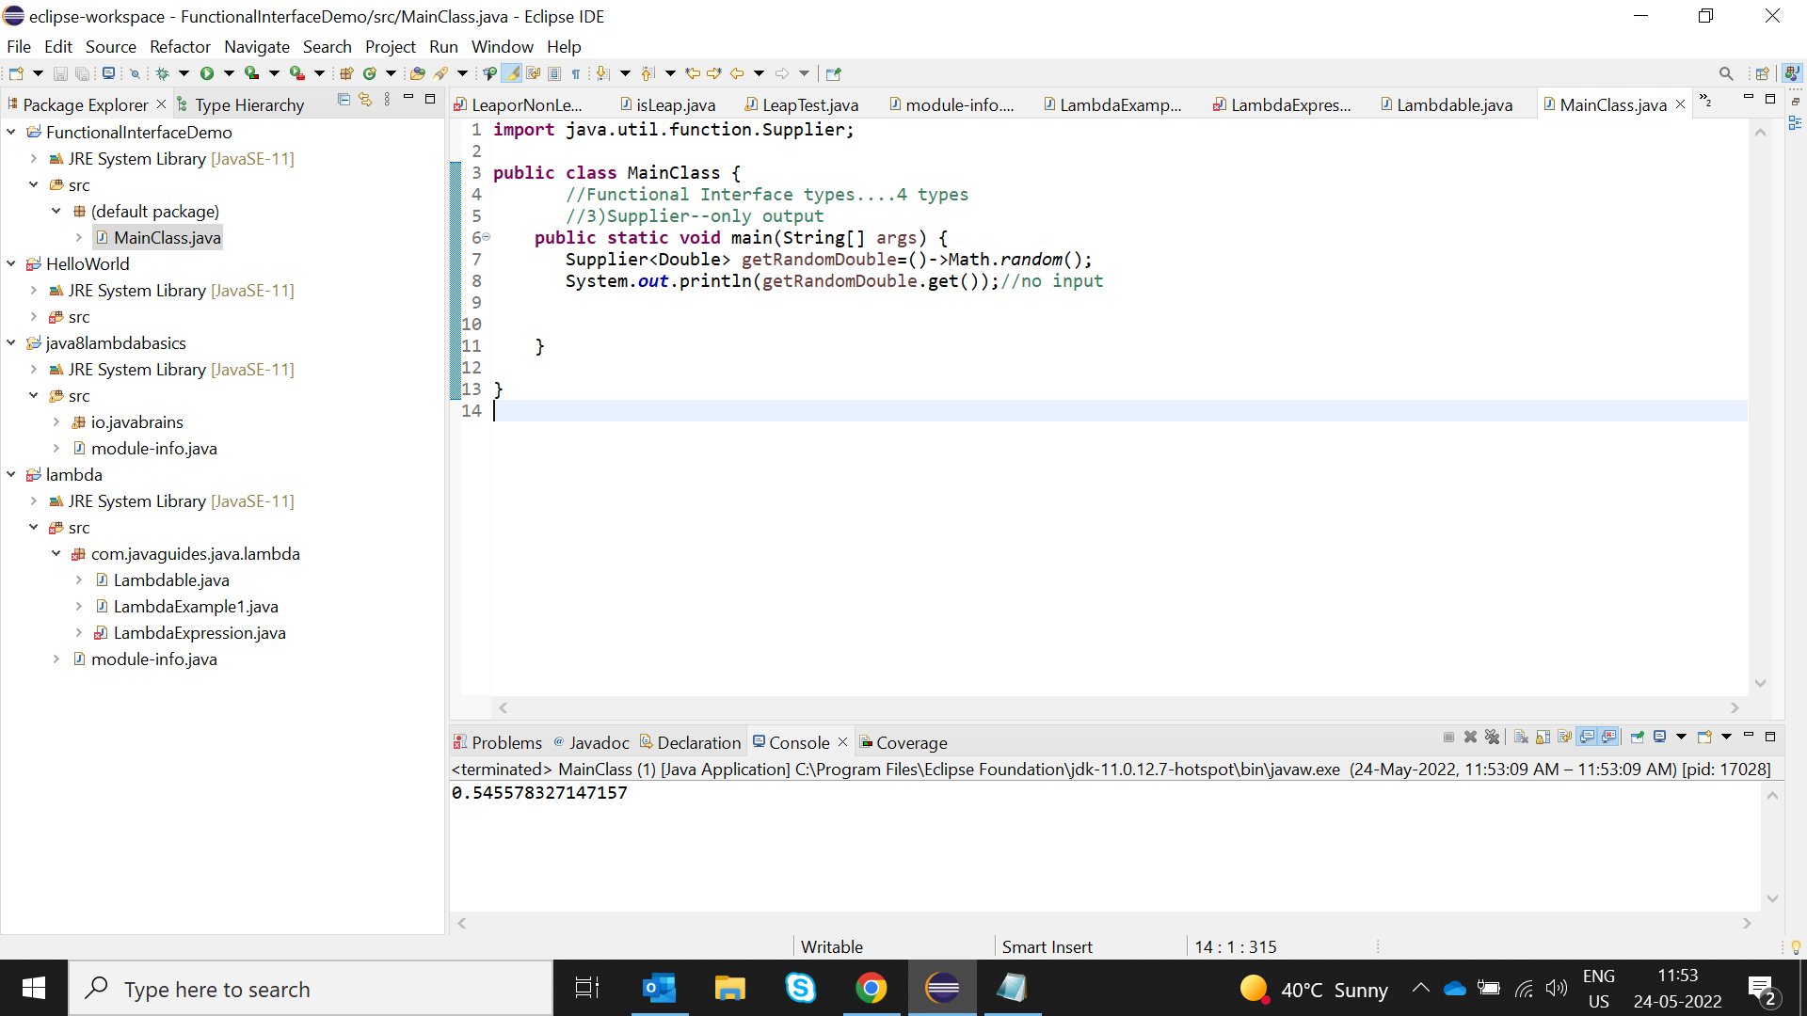

Section4: Remove the words that have odd lengths from the list: HINT: Use one of the new methods from JDK 8. Use removeIf() method from Collection interface.

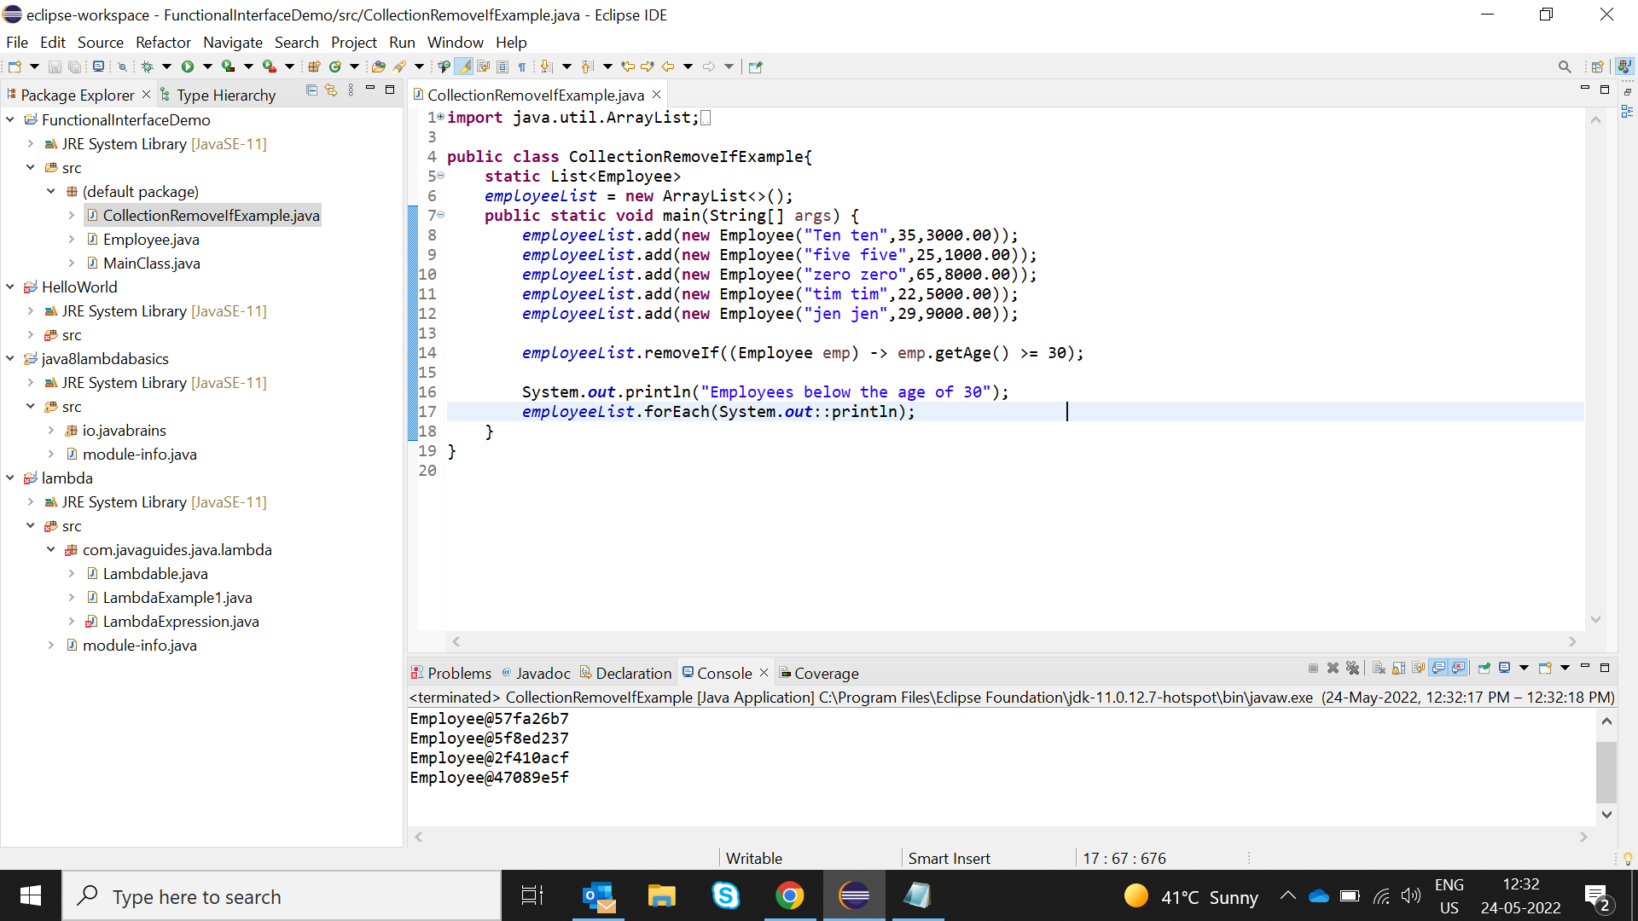

Section5: Create a String that consists of the first letter of each word in the list of Strings provided. Hint: Use Consumer interface & a StringBuilder to construct the result.

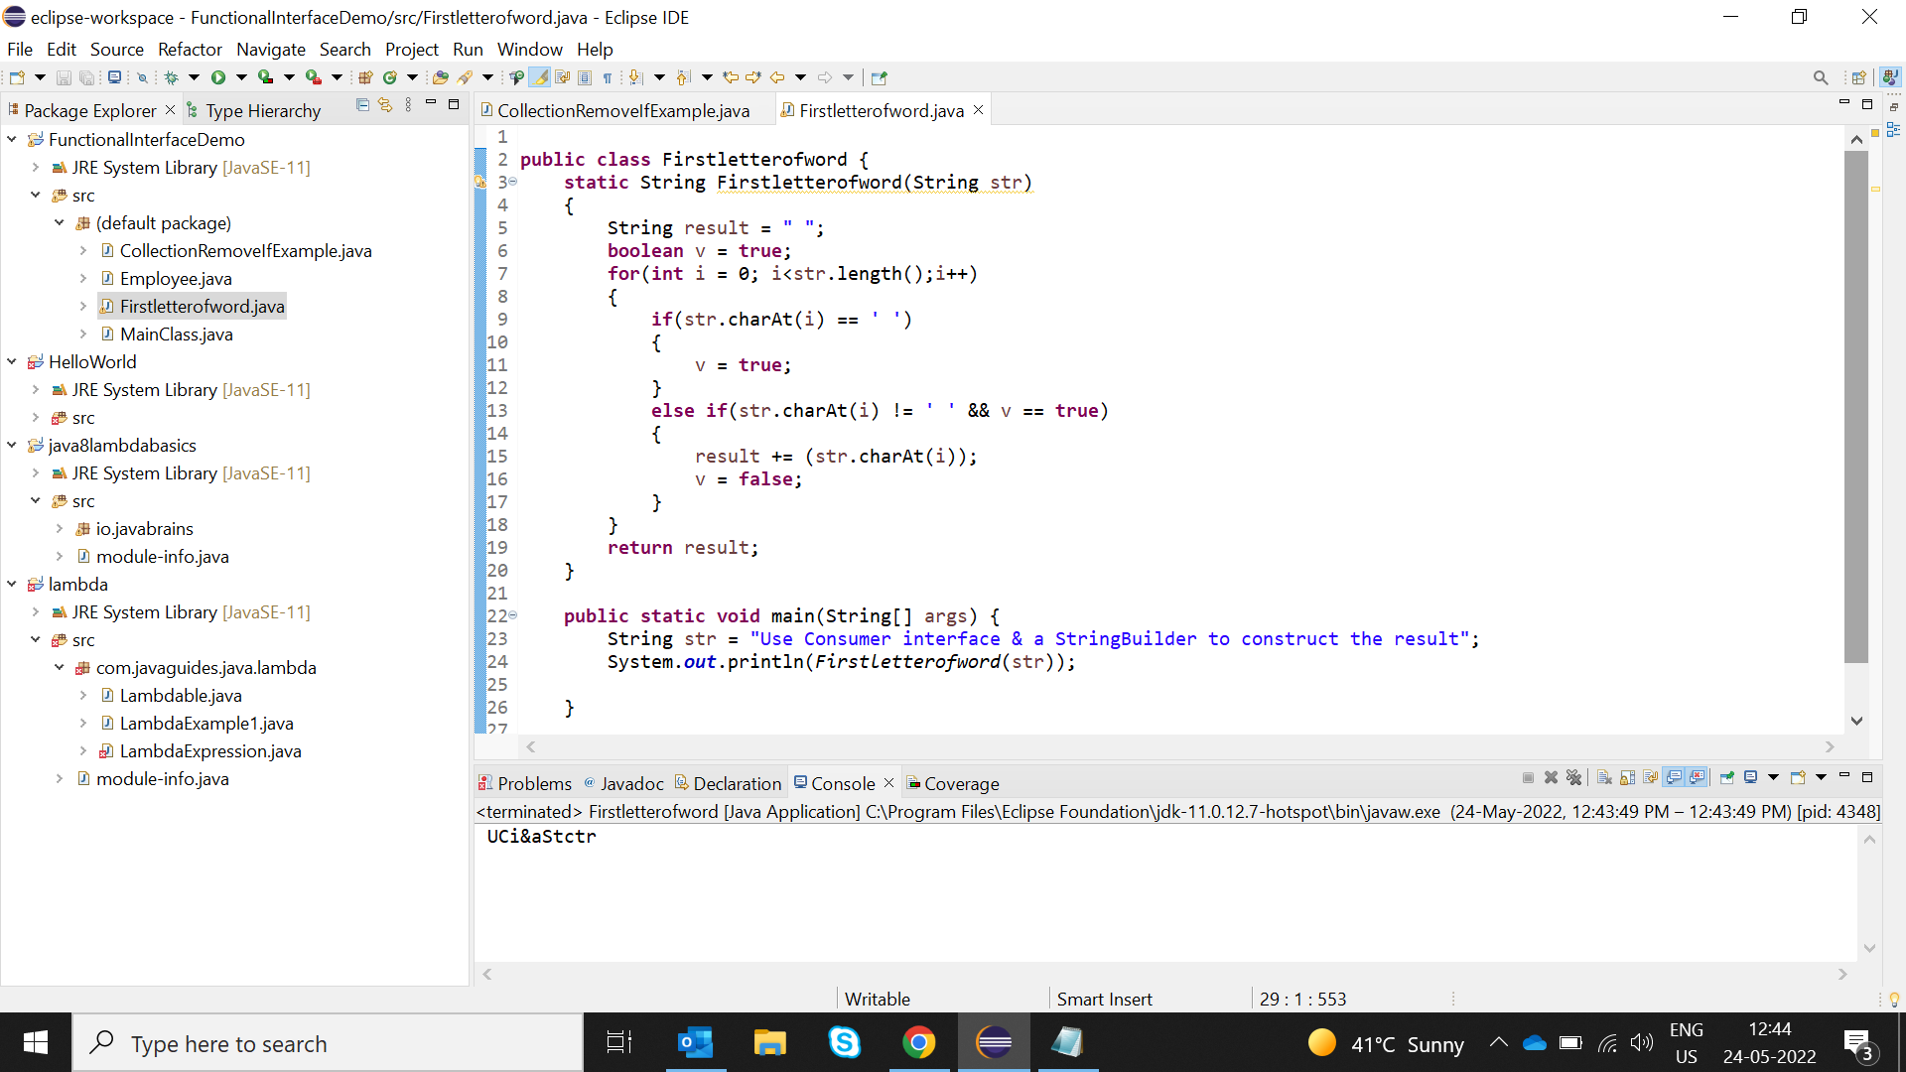

Section 6: Replace every word in the list with its upper case equivalent. Use replaceAll() method & UnaryOperator interface.

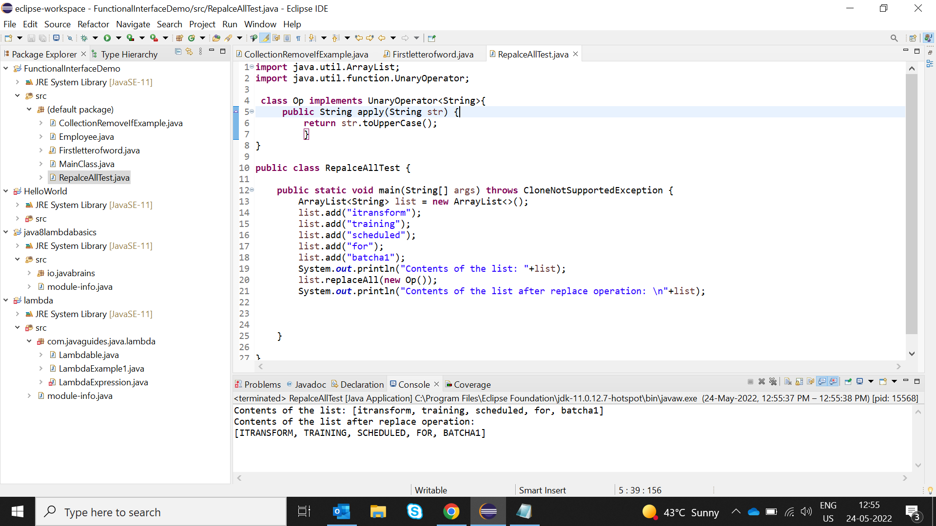

Section 7: Convert every key-value pair of the map into a string and append them all into a single string, in iteration order. Hint: Use Map.entrySet() method & a StringBuilder to construct the result String.

Section 8: Create a new Thread that prints the numbers from the list. Use class Thread & interface Consumer.

